UNO PLATFORM

The UNO Platform is Universal Windows Platform Bridge that allows UWP based code(c# and XMAL) to run on IOS, Android and WebAssembly. It provides the full API definitions of the UWP [Windows 10 2004 (19041)](https://docs.microsoft.com/en-us/windows/uwp/whats-new/windows-10-build-19041), and the implementation of parts of the UWP API, such as **Windows.UI.Xaml**, to enable UWP applications to run on these platforms.

1. UWP : In this implementation is done by using WebView and invoke JavaScript function to run charts. As webgl is supported in x64 CPU configuration .it is running on uwp windows app on x64 CPU currently.

Simple line chart and 3D chart is implemented . data generator is used for 3D chart point collection.

This are following screenshots from UWP app.

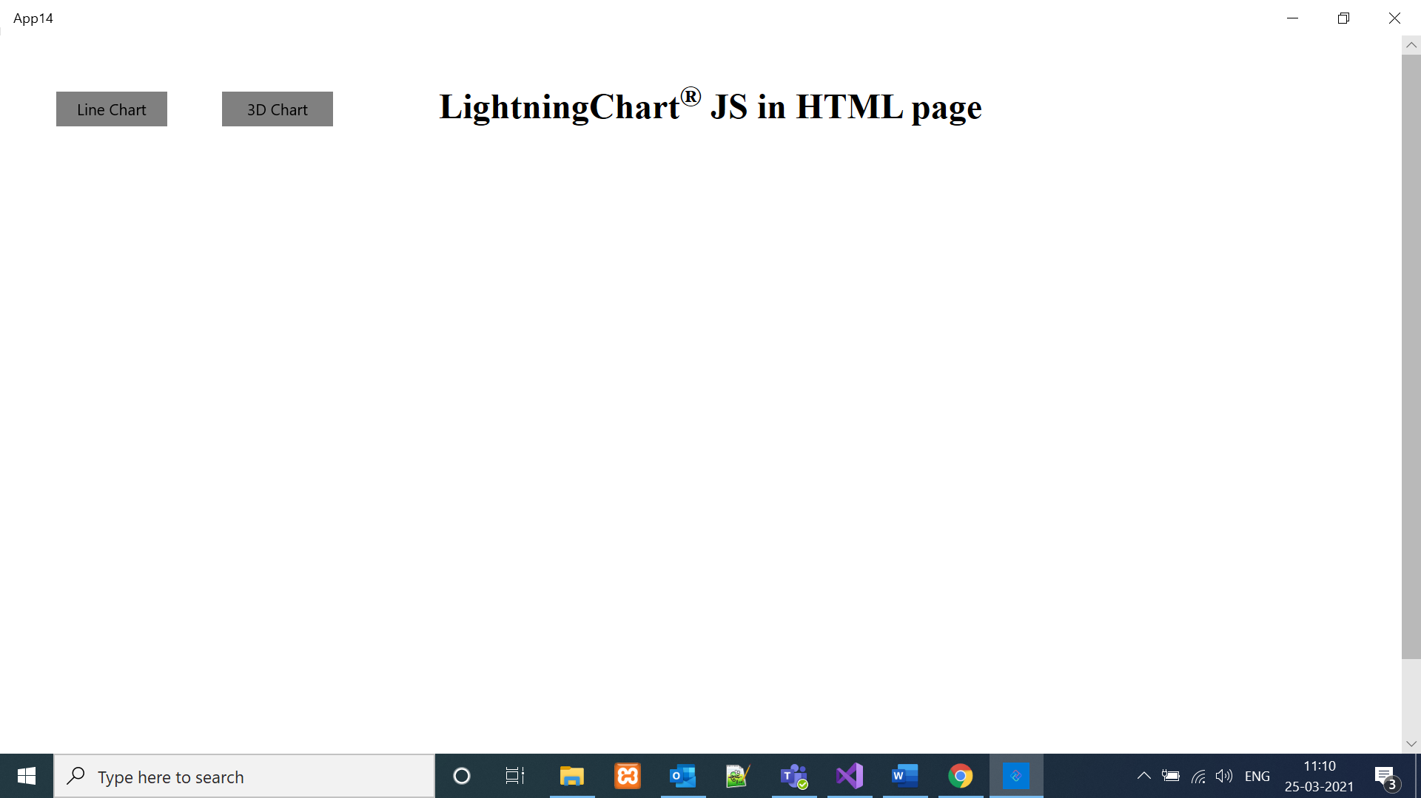

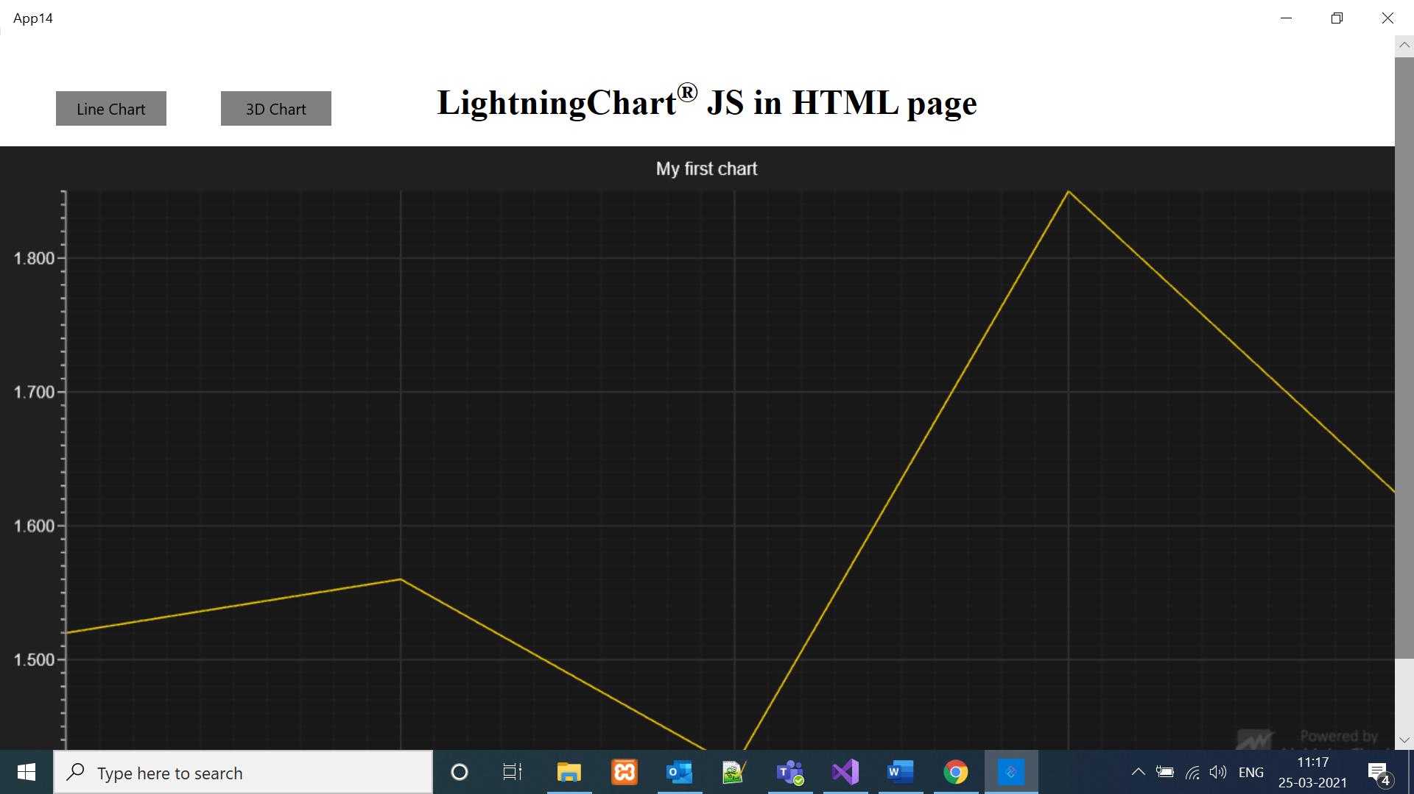

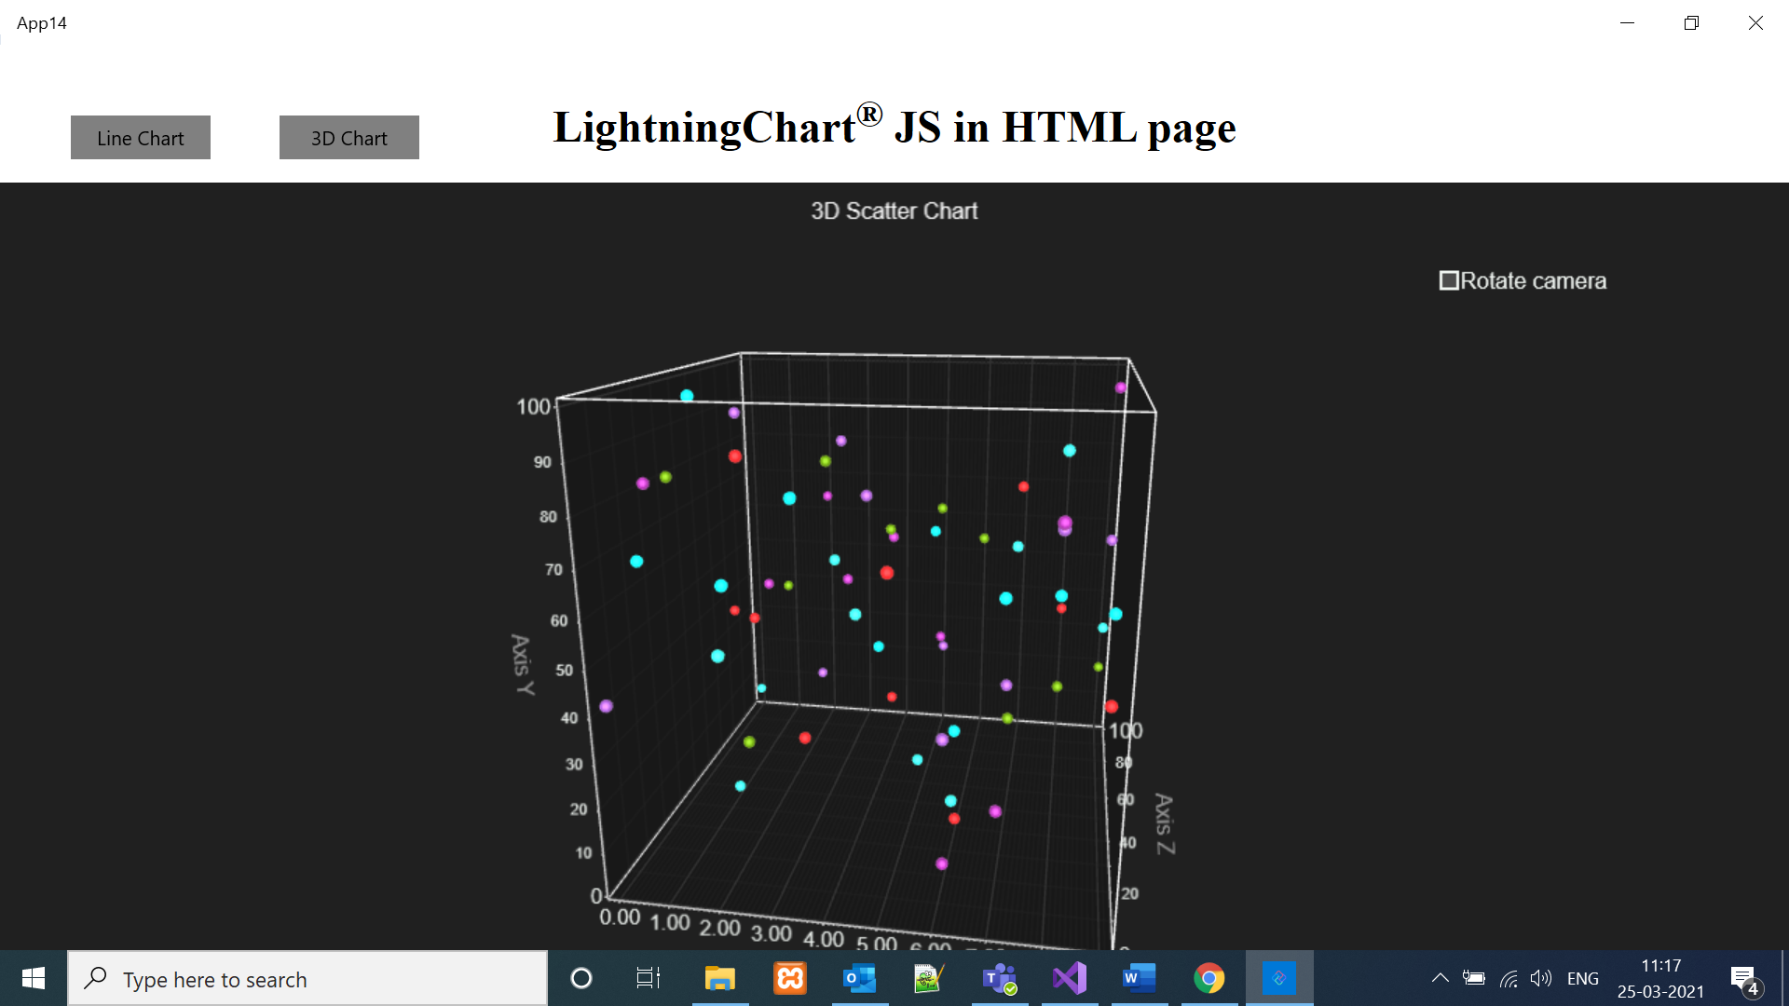

1. Android

Same UWP is code is running in case of android with webview implementation.

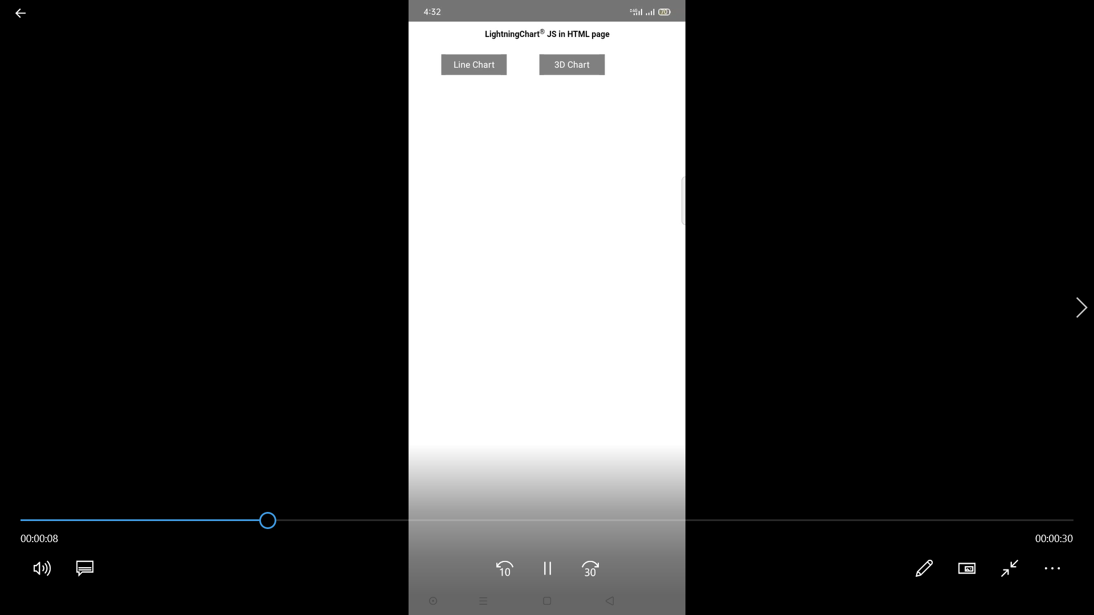

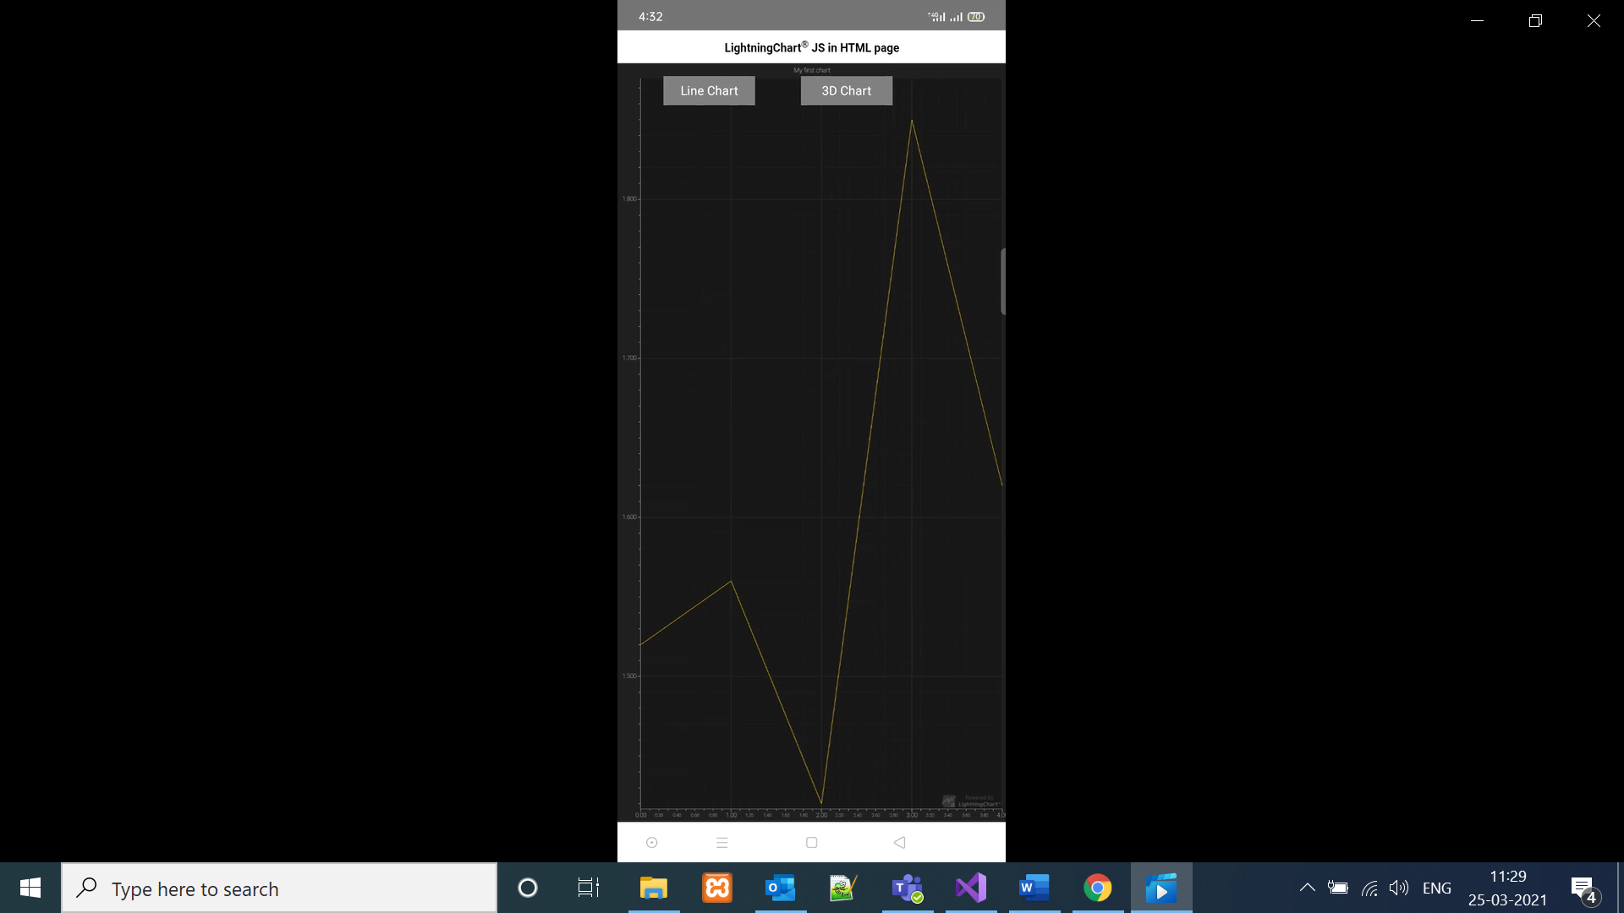

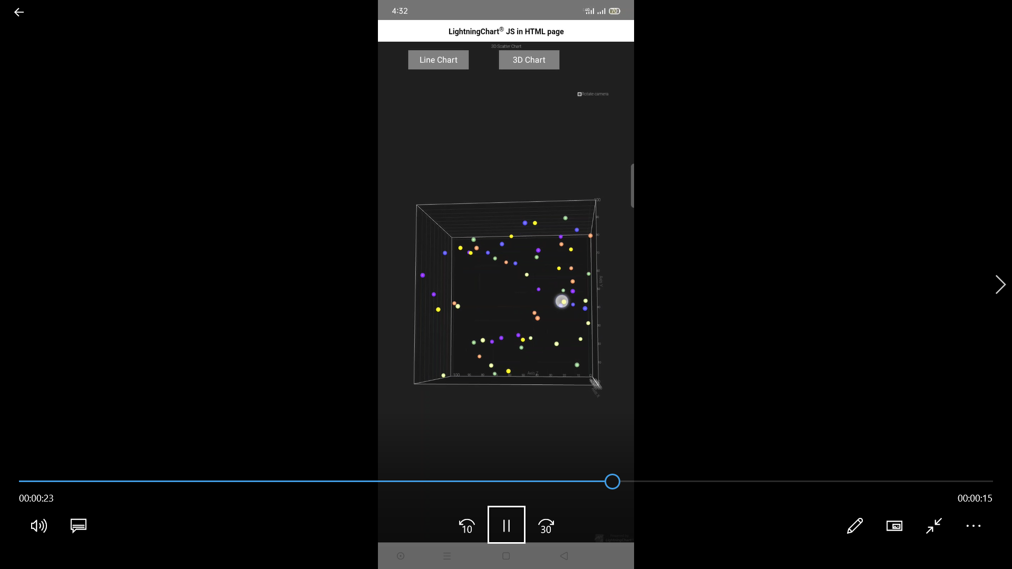

1. Wasm and skia wpf and host: we tried to implement in this .but after solving errors and some after applying various settings we are not able to run chart.then we come across one of the link which says in case of UNO most of thing are still not supporting and it is one of those.

Web view is not supported in wasm and skia ,so charts not implemented in this two platform.

1. IOS: Need to check on IOS device. Cause webgl is support can be found when we run on actual device.